Precise positioning
Space-saving and reliable complete systems
Measure positions, speeds and travel lengths reliably and precisely
Up to 0.008 mm/pulse for excellent measurement results
Quickly mounted and adjusted

The positions, speeds and travel lengths of conveyor belts, film and paper webs or cardboard packaging, for example, can be recorded safely and efficiently using the measuring systems from Wachendorff Automation.
With the new LMSMA2x and LMSMA3x measuring systems, we meet the highest requirements in an ideal way: constant and accurate measurement results through optimal, low-slip measurement in the most varied conditions; resolutions from 1.0 to 0.008 mm/pulse; small space requirement thanks to a compact design; long service lifetimes thanks to the high mechanical robustness of all the components; fast and flexible mounting to the machine. Wachendorff has significantly improved the adjustment possibilities of the complete systems, which are based on a spring arm with a central spring. This gives you constructive and valuable benefits:
The newly developed central adjustment with its 10° locking steps enables 36 alignment positions. In combination with the elongated holes of the mounting bracket, this gives you much more room for mounting.
The spring preload is adjustable in steps from 5 N to a maximum of 30 N preload. In combination with the measuring wheel, which is geared to the measuring surface, this guarantees the optimal contact pressure. When installing in the machine or making a readjustment, the preassembled systems can remain mounted during the commissioning process because the LMSMA systems from Wachendorff offer the option of fixing the spring arm in a resting position. The spring arm is then returned to the working position and continues to work at the previously set contact pressure.

More information: www.wachendorff-automation.com/lms

Bildmaterial (Wachendorff Automation):

Bild 1:

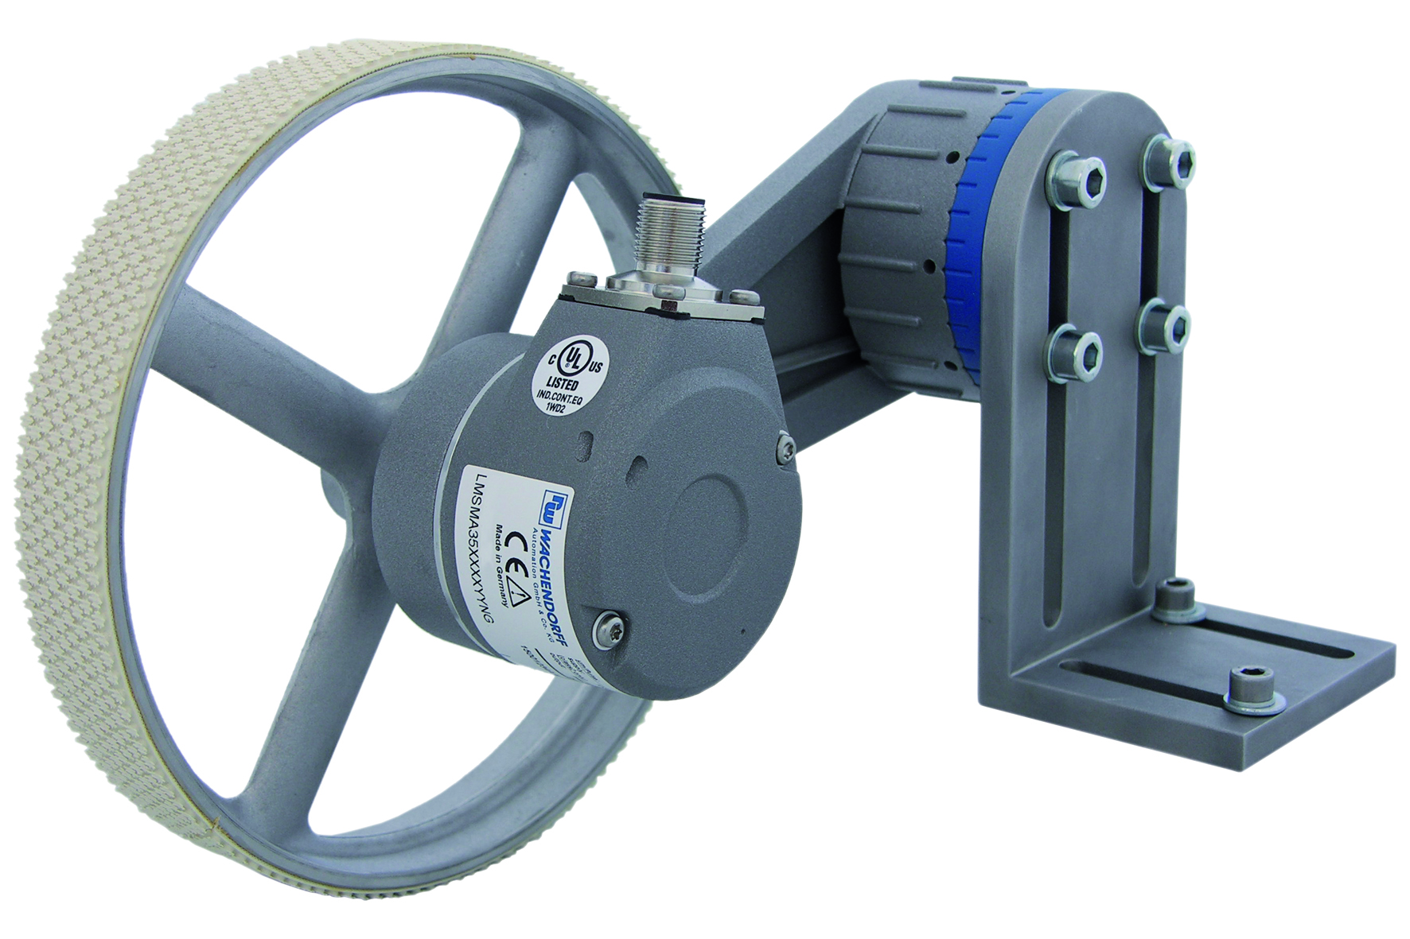

The LMSMA2x length measuring system can be mounted directly to the machine using the blue base plate because the dimensions of the holes in the blue base plate are geared to the mounting profiles currently on the market.
If direct mounting is not possible on the equipment, Wachendorff has the solution with the LMSMA3x length measuring system. Equipped with a highly adjustable mounting bracket that is preassembled at its pivot point, the LMSMA3x length measuring system enables the most varied mounting positions.

Bild 2:
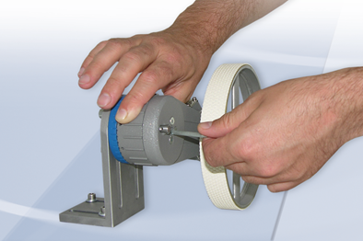

The LMSMA measuring systems offer constructive benefits. The newly developed central adjustment with its 10° locking steps enables 36 alignment positions. In combination with the elongated holes of the mounting bracket, this gives you much more room for mounting.
The spring preload is adjustable in steps from 5 N to a maximum of 30 N preload. In combination with the measuring wheel, which is geared to the measuring surface, this guarantees the optimal contact pressure.
When installing in the machine or making a readjustment, the preassembled systems can remain mounted during the commissioning process because the LMSMA systems from Wachendorff offer the option of fixing the spring arm in a resting position. The spring arm is then returned to the working position and continues to work at the previously set contact pressure.

