Contact for editorial materials:
Dirk Rott, Marketing Manager
Visit us in Hall 7, Stand 151

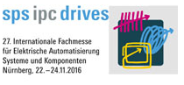

20 October 2016

Press release WA1604:
Fastest and most compact PROFINET encoder in the world
Image/text materials have been approved for publication in the specialised press (print and online). Please send us a specimen copy after publication. Many thanks in advance for your efforts.
________________________________________________________________________
Fastest and most compact PROFINET encoder in the world
Highly accurate and highly dynamic
Fast, precise and compact
Wachendorff Automation has extended the absolute encoder series WDGA by the Industrial Ethernet interface PROFINET-IRT.
With its new WDGA58F design, Wachendorff has succeeded in constructing the world's smallest design in an axial and radial direction. That saves valuable installation space and can therefore be crucial in new or refined machines, as the trend towards ever more compact systems is continuing undiminished. Despite this unique compact design, the high bearing loads ensure tremendous durability and maximum service lives.
The PROFINET encoders from Wachendorff are able to keep pace with the latest PLC technologies thanks to the minimum bus cycle time of 125 µs.
The single-turn area, with innovative QuattroMag® technology, provides a resolution of up to 16 bit, a precision of +/- 0.0878° (12 bit), a repeat accuracy of +/- 0.0878° (12 bit) and internal dynamics of 50 μs. In the area of the multi-turn, the Profinet encoders from Wachendorff come with maintenance-free and space-saving EnDra® technology.
Thanks to these highly accurate and highly dynamic technologies, the absolute encoders WDGA with magnetic scanning can be used in numerous applications, in which only absolute encoders based on optical principles could be used up until now.
Plant manufacturers and mechanical engineers also benefit from the modular principle utilised by Wachendorff Automation, in conjunction with the strictly applied LeanQ philosophy.
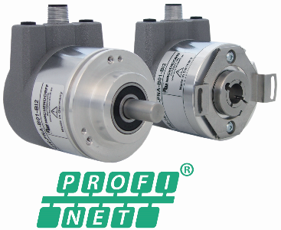
More information: http://www.wachendorff-automation.com/profinet
Image (Wachendorff Automation):
WA1604_PI_PROFINET_Drehgeber_20102016.jpg

